Computer Science Project

D.A.V. PUBLIC SCHOOL, ROHINI

**SCHOOL**

**ADMISSION & FEES**

**MANAGEMENT**

SUBMITTED BY: KHUSHAL KAPOOR

CLASS : XII-C

ROLL NO : 14

CBSE Roll No. ___________

**INDEX**

**S.NO. TOPIC**

1. Acknowledgement
2. Certificate
3. Introduction
4. User Defined Functions
5. Header Files
6. Source Code
7. Output
8. Flowchart
9. Bibliography

ACKNOWLEDGEMENT

I would like to convey heart fill regards to Mrs. SHALLU SAHA my computer science teacher who gave valuable suggestions and guidance and my team partner who accompanied me during the making of this project……

thank you madam and my partner for helping me to bring innovation in my project…****

**This Is Certified To Be The Bona Fide Work Of KHUSHAL KAPOOR Of Class XII-c In Making Computer Science (C++) Project In The Academic Year 2014-15 With The Help Of our Computer Science Teacher, Mrs. SHALLU SAHA .**

**TEACHER’S SIGN…...…………………**

**DATE.………………………**

**INTRODUCTION**

**This Project Contains a Program Based on School Admission & Fees Management , Which Covers Handling of its student’s Details and Their Accounts & fees Records…..**

**HEADER FILES USED**

* ***IOSTREAM.H***
* ***STRING.H***
* ***DOS.H***
* ***STDIO.H***
* ***CONIO.H***
* ***PROCESS.H***
* ***FSTREAM.H***

**FUNCTIONS CONTAINED IN CLASS**

*PUBLIC*

void constr();

void input_stud_new(int&);

void update_stud();

void display();

void display2();

int ret();

int srch_name(char v[ ])

void writefile();

**CLASS VARIABLES**

*PRIVATE*

*Char* *name , address, b, phone*

*long int* *str ,tfees , pfees , lfees*,

*inst_dn,s,x , inst_amt ,std*

*long double* *reg_no*

**User Defined Functions**

Class functions

* **constr ()-** This function is to give initial default values to the variables used.
* **Update_stud()-** This function is used for deposition of fees.
* **input** **_stud_new()**- This function is used to make new entry in the record by the user.
* **display ()-** This function is used to display the selected data of the student to the user.
* **display2**()- This function is used to display all the data of the student.
* **srch _name()-** This function is to search the data of student by getting name from user and comparing it with that of file.
* **ret()-** This function is used to return the reg_no.
* Global function
* pass()- This is a function for getting password.

## Header files

Iostream.h ::

 Contains the definition of basic_iostream class template, which implements formatted input and output. Handles bidirectional operations on single stream.

1. Cin (>>)-stands for console input, usually keyboard. It is used to input data by user.
2. Cout(<<)-stands for standard output, usually monitor/screen. Used to get standard output.

Fstream.h ::

An input/output stream that wraps a file stream buffer. Provides functions to open or close a file in addition to those of generic input/output stream.

Conio.h ::

1. Clrscr() :this function is used to clear the output screen.
2. Getch() :Gets a character from user but does not echo it on screen.

Process.h::

Exit()-the function is to terminate the program normally as soon as it is encountered.

Dos.h::

Delay()- this function is used to delay the output to screen by milliseconds as specified by the user.

String.h::

Strcmp()- it is used to compare two strings returning a value True if matched and False if not i.e 1 or 0.

Stdio.h::

Rename()-this function is to rename the file .

Remove()-this function is to remove the previously stored file.

Source Code

#include<iostream.h>

#include<string.h>

#include<dos.h>

#include<stdio.h>

#include<conio.h>

#include<process.h>

#include<fstream.h>

void load();

void pass(int );

void chpass();

class info

{

char name[50], address[100] ,b[5],phone[10];

long int str,tfees,pfees,lfees, inst_dn,s[5],x,inst_amt,std;

long double reg_no;

public:

info()

{

strcpy(name," ");

strcpy(address," ");

tfees=pfees=lfees=0;

inst_dn=0;

tfees=0;

std=0;

inst_amt=0;

}

void constr();

void input_stud_new(int&);

void update_stud();

void display();

void display2();

int ret();

int srch_name(char v[]);

};

void info::constr()

{

strcpy(name," ");

strcpy(address," ");

tfees=pfees=lfees=0;

inst_dn=0;

tfees=0;

std=0;

inst_amt;

}

void info::input_stud_new(int&m) // New entry

{

m++; x=0;

reg_no=m;

cout<<"enter name: ";

gets(name);

cout<<endl<<"standard (11 or 12): ";

cin>>std;

cout<<endl<<"address: ";

gets(address);

cout<<endl<<"phone no : +91";

gets(phone);

cout<<endl<<"stream : ";

cout<<endl<<"1: science";

cout<<endl<<"2: commerce"<<endl;

cin>>str;

switch(str)

{

case 1: cout<<endl<<"Choose subjects ";

cout<<endl<<"a: Physics :Rs 9600/yr";

cout<<endl<<"b: Chemistry :Rs 9600/yr ";

cout<<endl<<"c: Maths :Rs 9600/yr ";

cout<<endl<<"d: Computers :Rs 10000/yr";

cout<<endl<<"e: English :Rs 7000/yr"<<endl;;

gets(b);

break;

case 2: cout<<endl<<"Choose subjects ";

cout<<endl<<"f: accounts :Rs 9600/yr";

cout<<endl<<"g: bussiness std.:Rs 9600/yr ";

cout<<endl<<"h: Maths :Rs 9600/yr ";

cout<<endl<<"i: Economics :Rs 10000/yr";

cout<<endl<<"j: English :Rs 7000/yr"<<endl;;

gets(b);

break;

}

for(int q=0;b[q]!='\0';q++)

{

switch(b[q])

{

case 'a': tfees+=9600;

s[x]=1;

break;

case 'b': tfees+=9600;

s[x]=2;

break;

case 'c': tfees+=9600;

s[x]=3;

break;

case 'd': tfees+=10000;

s[x]=4;

break;

case 'e': tfees+=7000;

s[x]=5;

break;

case 'f': tfees+=9600;

s[x]=6;

break;

case 'g': tfees+=9600;

s[x]=7;

break;

case 'h': tfees+=9600;

s[x]=3;

break;

case 'i': tfees+=10000;

s[x]=8;

break;

case 'j': tfees+=7000;

s[x]=5;

break;

}

x++;

}

cout<<"total fees :"<<tfees;

getch();

inst_amt=tfees/5;

}

void info::update_stud() // deposit fees

{

if(inst_dn!=5)

{

gotoxy(34,4);

cout<<"Deposit fee ";

inst_dn++;

cout<<endl<<endl<<endl<<"Installment amount :";

cout<<inst_amt;

pfees+=inst_amt;

lfees=tfees-pfees;

}

}

void info::display() // Display Selected Record

{

cout<<"Reg. No: "<<reg_no;

cout<<endl<<"Name : ";

puts(name);

cout<<endl<<"Standard :"<<std;

cout<<endl<<"Address : ";

puts(address);

cout<<endl<<"Installments : "<<inst_dn<<"/ 5";

cout<<endl<<"Phone No. :";

puts(phone);

cout<<"Stream :";

if(str==1)

cout<<"SCIENCE";

else

cout<<"COMMERCE";

cout<<endl<<"******* S U B J E C T S *******";

for( int t=0;t<x;t++)

switch(s[t])

{

case 1: cout<<endl<<"Physics";

break;

case 2: cout<<endl<<"Chemistry";

break;

case 3: cout<<endl<<"Maths";

break;

case 4: cout<<endl<<"Computer";

break;

case 5: cout<<endl<<"English";

break;

case 6: cout<<endl<<"Accounts";

break;

case 7: cout<<endl<<"Bussiness std.";

break;

case 8: cout<<endl<<"Economics";

break;

}

cout<<endl<<"Total Fees :"<<tfees;

cout<<endl<<"fees paid :"<<pfees;

cout<<endl<<"fees left :"<<lfees;

}

void info::display2() // display all records

{

cout<<endl<<endl<<" Reg no :"<<reg_no;

cout<<endl<<" Name :"<<name;

cout<<endl<<" Stream :";

if(str==1)

cout<<"SCIENCE";

else

cout<<"COMMERCE";

cout<<endl<<"*.*.*.*.*.*.*.*.*.*.*.*.*.*.*.*.*.*.*.*.*.*.*.*.*.*.*.*.*.*.*.*.*.*.*.*.*.*.";

}

int info::ret() //return the reg_no.

{

return(reg_no);

}

int info::srch_name(char v[]) //search by name

{

int w;

w=strcmp(v,name);

if(w==0)

display();

return w;

}

void main() // Main

{

textcolor(RED);

textbackground(WHITE);

clrscr();

info i;

fstream f1,f2,f3,f4;

int p=0 , g=0,o=0,y,m=0,opt,jkl=0,ctr=0;

char v[50],pswrds[50];

clrscr();

gotoxy(26,7);

cout<<"***** D.A.V. PUBLIC SCHOOL ***** " ;

gotoxy(26,8);

cout<<" for commerce and science only";

delay(1000);

load();

f1.open("sdc.dat",ios::in);

if(f1.fail())

m=0;

else

{

while(!f1.eof())

{

f1.read((char*)&i,sizeof(i));

m=i.ret();

}

}

f1.close();

f4.open("password.dat",ios::in);

f4>>pswrds;

f4.close();

for(int yr=0;pswrds[yr]!='\0';yr++);

yr--;

jkl=m;

clrscr();

pass(yr);

clrscr();

do

{

flag3:

clrscr();

cout<<endl<<"Choose What To Do";

cout<<endl<<endl<<"1: Enter A new Entry.";

cout<<endl<<"2: Deposit Fees.";

cout<<endl<<"3: Show a particular record.";

cout<<endl<<"4: Show All Records";

cout<<endl<<"5: Total No Of Student In Institute";

cout<<endl<<endl<<"6: Delete a record";

cout<<endl<<"7: Settings";

cout<<endl<<"8: Sign Out"<<endl;

cin>> y;

switch(y)

{

case 1: clrscr();

i.constr();

f1.open("sdc.dat",ios::out|ios::ate);

jkl++;

i.input_stud_new(m);

f1.write((char*)&i,sizeof(i));

f1.close();

clrscr();

gotoxy(34,7);

cout<<" Saving Your Updates ";

delay(1000);

clrscr();

gotoxy(34,7);

cout<<" Done !";

delay(1000);

break;

case 2: clrscr(); o=0;p=0;

f1.open("sdc.dat",ios::in);

while(!f1.eof())

{

f1.read((char*)&i,sizeof(i));

i.display2();

p++;

getch();

if(p%10==0)

{

break;

}

}

f1.close();

clrscr();

cout<<"enter the registration number of the student : ";

cin>>g;

f1.open("sdc.dat",ios::in);

while(!f1.eof())

{

f1.read((char*)&i,sizeof(i));

o=i.ret();

if(g==o)

{

i.update_stud();

break;

}

}

i.display();

getch();

f1.close();

clrscr();

gotoxy(34,7);

cout<<" Saving Your Updates ";

delay(2000);

clrscr();

gotoxy(34,7);

cout<<" done !";

break;

case 3: clrscr(); o=1;p=0;

f1.open("sdc.dat",ios::in);

cout<<"enter the name of the student : ";

gets(v);

while((!f1.eof())&&(o!=0))

{

f1.read((char*)&i,sizeof(i));

o=i.srch_name(v);

}

getch();

f1.close();

break;

case 4: clrscr(); p=0;

if(jkl!=0)

{

f1.open("sdc.dat",ios::in);

while(!f1.eof())

{

f1.read((char*)&i,sizeof(i));

if(f1.eof()!=1)

{

i.display2();

p++;

getch();

if(p%10==0)

clrscr();

}

}

f1.close();

}

else

cout<<"file is empty ";

getch();

break;

case 5: clrscr();

cout<<"Total No Of Students In The Institute :"<<jkl;

getch();

break;

case 7: clrscr(); int lk=1; char e[50],z[50];

gotoxy(5,5);

while(ctr!=3)

{

clrscr();

ctr++;

cout<<" Enter Password : ";

gets(e);

f4.open("password.dat",ios::in);

f4>>z;

lk=strcmp(z,e);

if(lk==0)

{

ctr=3;

clrscr();

gotoxy(31,2);

cout<<" A D M I N S E T T I N G S";

cout<<endl<<"1: delete all data ";

cout<<endl<<"2: create backup ";

cout<<endl<<"3: restore from backup ";

cout<<endl<<"4: change password\n ";

cout<<endl<<"5: Back To Main Menu ";

cin>>opt;

switch(opt)

{

case 1: clrscr(); int w;

cout<<" Are you sure you want to delete all data ?";

cout<<endl<<" WARNING : please backup your data. ";

cout<<endl<<endl<<" 1: yes ";

cout<<endl<<" 2: no";

cin>>w;

if(w==1)

{

remove("sdc.dat");

}

break;

case 2: clrscr();

if(jkl!=0)

{

gotoxy(34,7);

cout<<" creating backup ... ";

delay(2000);

gotoxy(34,7);

cout<<" backup created ";

gotoxy(34,8);

cout<<" file name : sdc_backup.txt ";

getch();

f1.open("sdc.dat",ios::in);

f2.open("sdc_bckp.dat",ios::out);

char jh;

while(!f1.eof())

{

f1>>jh;

f2<<jh;

}

f1.close();

f2.close();

}

else

cout<<" ERROR : No data in file ";

break;

case 3: clrscr();

f2.open("sdc_bckp.dat",ios::in);

if(f2.fail())

{

cout<<" Backup Not Available ";

getch();

}

else

{

f2.close();

remove("sdc.dat");

rename("sdc_bckp.dat","sdc.dat");

}

break;

case 4: chpass();

break;

case 5: goto flag3;

default: cout<<" Wrong input ";

}

}

else

cout<<"try again";

}

break;

case 6: char x[50];int r;

clrscr();

jkl--;

f1.open("sdc.dat",ios::in);

f3.open("temp.dat",ios::out);

cout<<"\n Enter the name of student whose record is to be deleted: ";

gets(x);

clrscr();

while(!f1.eof())

{

f1.read((char*)&i,sizeof(i));

if(f1.eof()!=1)

{

r=i.srch_name(x);

if(r!=0)

f3.write((char*)&i,sizeof(i));

}

}

f3.close();

remove("sdc.dat");

rename("temp.dat","sdc.dat");

f1.close();

f3.close();

break;

case 8: clrscr();

gotoxy(34,7);

cout<<" Signing Out ";

delay(1000);

clrscr();

gotoxy(27,7);

cout<<" \t Have A GOOD DAY !"<<endl<<endl;

cout<<" \t \t A PROJECT BY KHUSHAL. HOPE YOY ENJOY......:)";

delay(1000);

break;

default: cout<<endl<<" I n v a l i d I n p u t ";

}

}while(y!=8);

}

void load() // Loading

{

int i,j;

gotoxy(50,20);

cout<<"Loading your data";

for(int l=0;l<2;++l)

{

delay(300);

cout<<".";

}

for(i=1;i<7;i++)

{

if(i%2!=0)

{

gotoxy(3,5);

cout<<".";

delay(150);

gotoxy(5,4);

cout<<".";

delay(150);

gotoxy(8,4);

cout<<".";

delay(150);

gotoxy(10,5);

cout<<".";

delay(150);

gotoxy(10,6);

cout<<".";

delay(150);

gotoxy(8,7);

cout<<".";

delay(150);

gotoxy(5,7);

cout<<".";

delay(150) ;

gotoxy(3,6);

cout<<".";

delay(150) ;

}

if(i%2==0)

{

gotoxy(3,5);

cout<<" ";

delay(150);

gotoxy(5,4);

cout<<" ";

delay(150);

gotoxy(8,4);

cout<<" ";

delay(150);

gotoxy(10,5);

cout<<" ";

delay(150);

gotoxy(10,6);

cout<<" ";

delay(150);

gotoxy(8,7);

cout<<" ";

delay(150);

gotoxy(5,7);

cout<<" ";

delay(150) ;

gotoxy(3,6);

cout<<" ";

delay(150) ;

}

}

delay(500);

clrscr();

int tr=22,te;

for(int ty=1;ty<=tr;ty++)

{

delay(50);

for(te=2;te<=ty;te++)

{

gotoxy(0,0);

cout<<" D.A.V.P.S ";

}

}

gotoxy(25,14);

for(int ctr=1;ctr<=34;ctr++)

{

delay(100);

cout<<char(219);

}

delay(2000);

gotoxy(32,14);

cout<<"Loading completed";

delay(500);

clrscr();

gotoxy(38,14);

cout<<"Welcome";

delay(1000);

}

void pass(int yr) // Login

{

int k=0;

fstream f4;

f4.open("password.dat",ios::in);

int chk=0;

char a[50];

char ps[50];

f4>>a;

f4.close();

chk++;

flag1:

clrscr();

cout<<"USERNAME : D.A.V.";

cout<<"\nPASSWORD : ";

for(k=0;k<=yr;k++)

{

ps[k]=getch();

cout<<"*";

}

ps[k]='\0';

getch();

int f=strcmp(a,ps);

getch();

if(f==0)

cout<<"\n\nAccess Granted.";

else

{

cout<<"\n\nAccess Denied.";

if(chk!=3)

{

cout<<chk;

chk++;

cout<<endl<<endl<<"try again."<<endl;

getch();

goto flag1;

}

else

exit(0);

}

}

void chpass() // change password

{

clrscr();

fstream f5;

char l[50],a[50],m[50],n[50];

f5.open("password.dat",ios::in);

cout<<"Enter current password : ";

gets(l);

f5>>a;

int k=strcmp(a,l) ;

if(k==0)

{

f5.close();

cout<<endl<<"enter new password : ";

gets(m);

cout<<endl<<"confirm new password : ";

gets(n);

int q=strcmp(m,n);

if(q==0)

{

clrscr();

gotoxy(34,7);

cout<<"Password changed";

f5.open("password.dat",ios::out);

f5<<m;

delay(1000);

clrscr;

}

else

{

cout<<endl<<"password not matched" ;

getch();

}

}

else

{

cout<<"Wrong password";

getch();

} }

**OUTPUT**

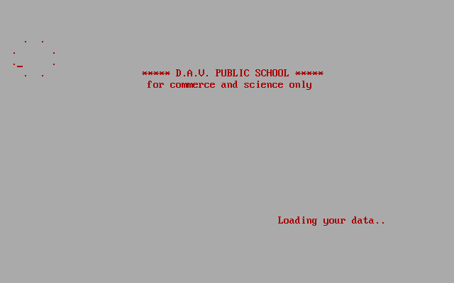

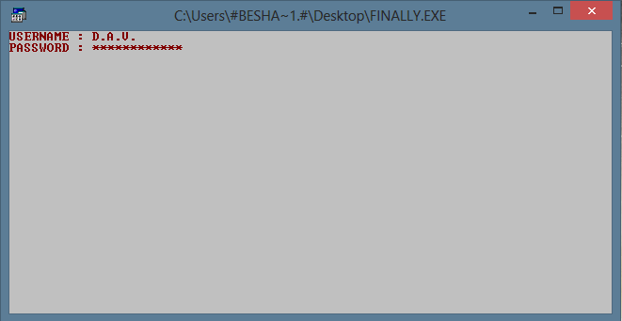

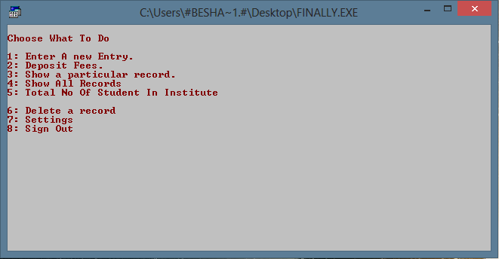

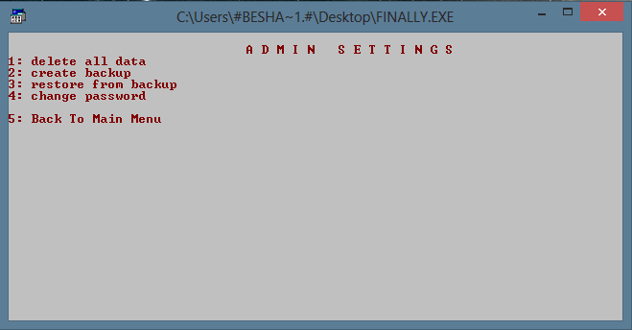

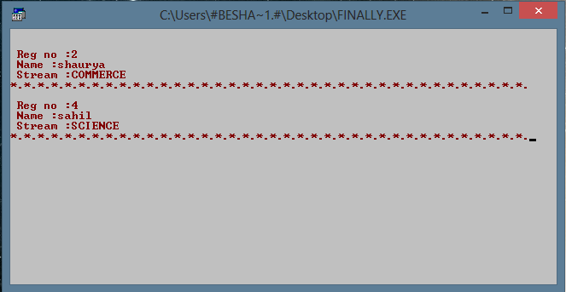

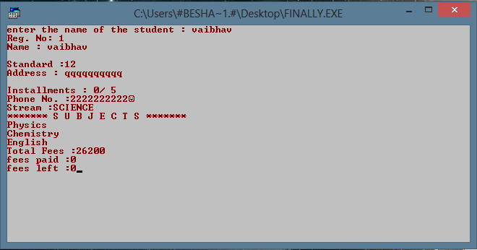

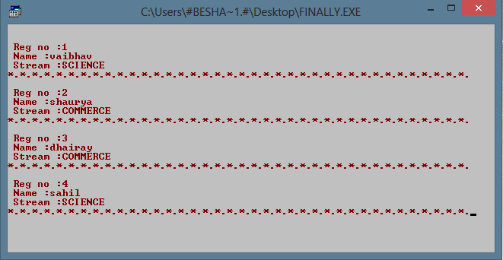

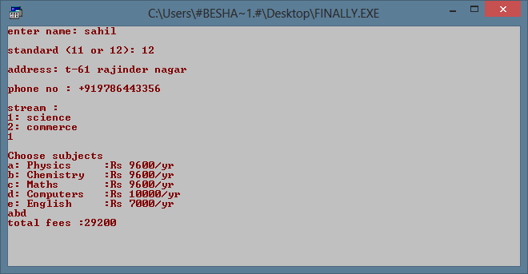

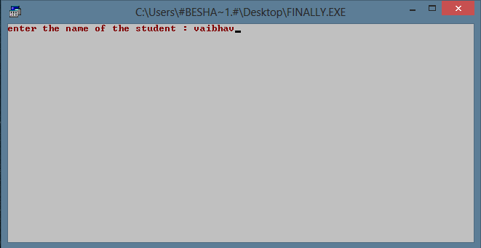

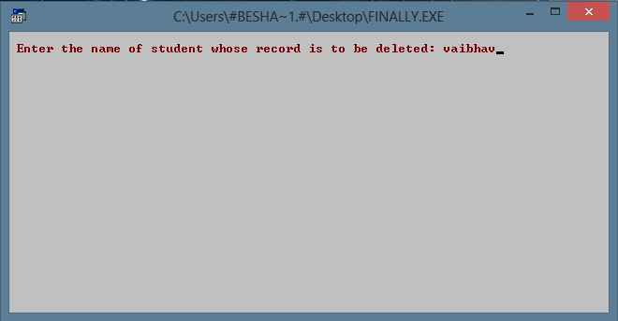

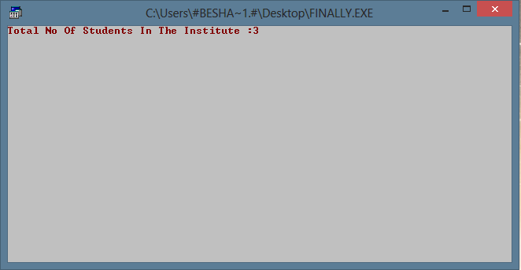

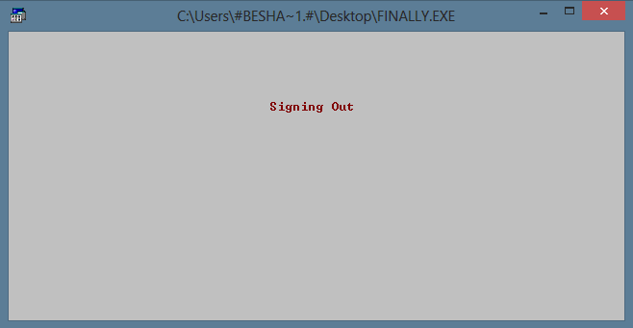

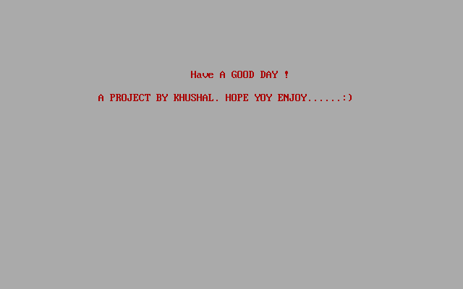

**BIBLIOGRAPHY**

1. **SUMITA ARORA C++ ( CLASS XII)**
2. [**WWW.GOOGLE.CO.IN**](http://WWW.GOOGLE.CO.IN)